**BUSINESS REQUIREMENT DOCUMENT**

**InfineX Website Development**

**(includes website landing page development and website database tool development)**

**EXECUTIVE SUMMARY**

Strengthened by the execution of InfineX’s land and expand business/sales strategy, InfineX is positioned to launch externally with a website to support customer satisfaction and success. The main purpose of the InfineX web launch is to truly establish the InfineX brand and to create a transactional website with similar functionalities to what competitors offer their customers. To be a dominant industry leader, InfineX’s website must provide fundamental engineering resources at a high-degree of simplicity and ease-of-use. The usability of a flexible content management system infrastructure (parametric search and cross reference database tools) and a sample program implementation will be two key factors that differentiate InfineX.

**PROJECT TEAM**

|  |  |  |  |
| --- | --- | --- | --- |
| **Core Team Members** | | | |
| **Executive Sponsor** | **Doug Britt** | **President IEI** | **San Jose** |
| **Management Sponsor** | **Rajeev Chowdhry** | **Sr. Director Business Transformation** | **Plano** |
| **InfineX Management Sponsor** | **Rene Rodriguez** | **Sr. Director Business Development** | **Austin** |
| **IT Support** | **Rodrigo Camargo** | **Sr. IT Program Manager** | **Plano** |
| **InfineX Technology Support** | **Hubert Bergner** | **Director Business Development** | **Althofen** |
| **InfineX Marketing Support** | **Bridget Wilson** | **Marketing Manager** | **Austin** |

**PURPOSE**

To create a high-quality, dynamic InfineX external website that establishes trust in the marketplace, generates brand awareness, supports customer satisfaction, and leads to revenue growth

**GOALS**

* Build InfineX brand awareness
* Become an established industry leader for standard electronic components
* Provide engineering design tool interaction for ease-of-use customer functionality
* Generate leads and increase conversion rates
* Support business revenue growth

**OBJECTIVES**

PHASE I

* Meet industry standards (parametric search, cross reference, tech docs)
* Provide dynamic information to current/potential customers
* Implement search engine optimization (SEO)
* Display structured, organized content (with effective call to actions)
* Flexible content management system
* Fulfill user-friendly, customer-oriented expectations
* Sample program functionality with shopping cart and fulfillment capabilities
* Allow mobile friendly format capability
* Encompass web analytics
* Integrate various media platforms (images, videos, PDFs/Excel, community links/blogs, database platforms with filtering capability, social media platforms, site search capability)
* Able to capture leads (login functionality and back-end forms)

PHASE II

* Ecommerce and fulfillment capability
* Select language capability

**HIGH-LEVEL SCOPE REQUIREMENTS**

* Website domain
* Email domain
* Website page creation: multiple landing pages
* Website database tool creation: parametric search with filtering options and download capabilities
* Website database tool creation: cross reference look-up (a search that provides a best fit InfineX part for a competitor part that is entered)
* Website back-end web analytics
* Website secure login capabilities
* Website shopping cart with fulfillment center capabilities

**RESOURCE REQUIREMENTS**

* Internal resource / External resource needs to be scoped

ASSUMPTIONS

* To use internal expertise resources where feasible
* InfineX has not contacted third-party vendors for this project
* Corporate Marketing has recommended that InfineX use: Belding Associates (belding.com)

Baseline Services (at a cost) include: Web Landing Page, WordPress Web Site (5-pages); Web Site Maintenance

Sample of their website work:

<http://www.zingsolar.com/> (Wordpress)

<http://www.crawfordcustomhomes.com/> (Wordpress)

<http://www.olea.com/> (Wordpress)

<http://jalenrose.com/> (Wordpress)

<http://www.mycommunitychampion.com/> (Wordpress)

<http://www.coordinated.com/> (Wordpress)

<https://www.susanshealthygourmet.com/> (Wordpress)

<http://guidryortho.com/> (Wordpress)

<http://aquahydrate.com/> (in Joomla)

* Previous InfineX Marketing team recommended to use: R/GA (rga.com/#about); no captured notes to support rationale
* Open for vendor recommendations
* Flex owns infinex.com domain and has control of DNS servers
* Project includes, easily maintainable:

1. Website platform development (website that contains multiple landing pages)
2. Website backend database tools (content management system – parametric search, cross reference look-up, documents)

* Digikey’s website, digikey.com, has been deemed as best in the industry for “Product Search” – InfineX criteria: simple, customer friendly, filter capabilities, export download capabilities, data sheet download capabilities, sample ordering capabilities
* Test users of the website and database tools need to be electronic design engineers and procurement/sourcing team representatives
* Existing internal tools include: Windchill, Command Center, InfineX Sharepoint Intranet, Flex Customer Extranet Portal for InfineX
* This requirement document does not outline the website launch program plan. A launch plan will need to be developed. This requirement document focuses on the high-level needs for a website landing page development and website database tools development)

CONSTRAINTS

* Website must allow for maintenance flexibility
* InfineX brand name will likely change; InfineX team actively pursuing resolutions with Legal and Corporate Marketing
* New domain will likely need to be procured

**BACKGROUND**

To-date, new and prospect customers are unable to find InfineX on the internet. Exception: there are mentions of InfineX on the flextronics.com website at <https://www.flextronics.com/industry-expertise/components> and <https://www.flextronics.com/flex-advantage/sketch-to-scale>.

Current and existing customers are able to access an informational web page through the FlexPortal Customer Extranet site. The InfineX Customer Extranet Portal (<https://extranet.flextronics.com/infinex/INX/InfineX.aspx?PageView=Shared>) is by membership only with unique, registered login accounts.

**BUSINESS FUNCTIONAL REQUIREMENTS**

Definition of prioritization

|  |  |  |
| --- | --- | --- |
| **VALUE** | **RATING** | **DESCRIPTION** |
| 1 | Critical | Critical to the success of the project |
| 2 | High | High priority (but the project can be implemented at a bare minimum without this) |
| 3 | Medium | Somewhat important, as it provides some value (but the project can proceed without it) |
| 4 | Low | Low priority; “nice-to-have” feature, if time and cost allow it |
| 5 | Phase II / Future | Out of scope for this project (has been included here for a future release) |

Requirements: functionality areas covering: general/basic; security; reporting; usability

|  | **RATING** | **DESCRIPTION** | **RATIONALE** |
| --- | --- | --- | --- |
|  | 1 | Industry standard website with multiple landing pages that integrates:   * various media platforms and displays content in a structured, organized manner (top navigation tabs, homepage critical content above the page fold – ease of navigation, organization of site, access speed, value of content and product search engine) * flexible/maintainable content management system * search engine optimization capabilities * shopping cart capabilities * fulfillment back-end capabilities * international shipping * order tracking communication capabilities * back-end web analytics | Industry standard is necessary to compete in the marketplace for brand awareness and leadership authority |
|  | 1 | Lead generation functionality as an output of targeted marketing initiatives and ecommerce/sample capabilities:   * lead generation with back-end forms | Capture customer interest/inquiry to fill the prospect sales funnel and qualify the lead |
|  | 5 | Ecommerce functionality as an output of Parametric/Part Number search and Cross Reference:   * ability to view pricing (USD) and inventory stock quantities (availability/lead times) * shopping cart capabilities * purchase with promotion code and credit card options * fulfillment back-end capabilities * international shipping * order tracking communication capabilities | Supports increase revenue growth |
|  | 1 | Sample program functionality as an output of Parametric/Part Number search/Cross Reference on products:   * ability to view inventory stock quantities (availability/lead times) * shopping cart capabilities * fulfilment back-end capabilities * international shipping * order tracking communication capabilities | Capture customer interest/inquiry to fill the prospect sales funnel and qualify the lead |
|  | 1 | Parametric data search functionality to access InfineX portfolio Part Numbers:   * parametric values search to find correct InfineX part by part number * output includes access to data sheet (and recommended data sheets) * output includes search to be exported into downloadable formats   source file: Excel document; output is an interactive interface (back-end database) that displays criteria filtering options (with only appropriate filters appearing – if/then scenarios | Supports design win growth |
|  | 1 | Product taxonomy index / product Part Number search engine:   * search field capabilities * product taxonomy structure (to search by category/sub-categories) * application taxonomy structure (to search by market application) * ability to type in (partial/full) Part Number * output includes access to data sheet | Supports design win growth |
|  | 1 | Cross reference tool look-up capabilities by product family:   * ability to enter in a competitor part number and return the appropriate equivalent InfineX portfolio series/family * output includes access to crossed InfineX data sheet | Supports design win growth |
|  | 5 | Ecommerce distributor stock search functionality as an output of Parametric/Part Number search/Cross Reference on selected products:   * ability to view stock held at a distributor * ability to purchase from distributor | Supports increase revenue growth |
|  | 2 | Request for technical engineering support:   * lead generation with back-end forms | Capture customer interest/inquiry to fill the prospect sales funnel and qualify the lead |
|  | 5 | Engineering Design Tool Program   * simulation database tools that leverage parametric data to help design engineers make an InfineX product decision | Simulation tools that differentiate InfineX as an Industry leader; supports ease-of-use and design win growth |

**SCREENSHOT EXAMPLES OF PARAMETRIC SEARCH:**

See below for various examples

* InfineX proposed option
* Industry standard variations

1. An option provided by InfineX (using Capacitors as an example):
   1. Option to search Part Number
   2. Option to click on Commodity sub-category (sub-categories link to expandable menu)
   3. Then, click at the Series level to be taken to the parametric table
   4. The view at the parametric table is at a series family level or a full series portfolio Part Number level

Rationale: controlled filters allow for the user to always receive a findable search

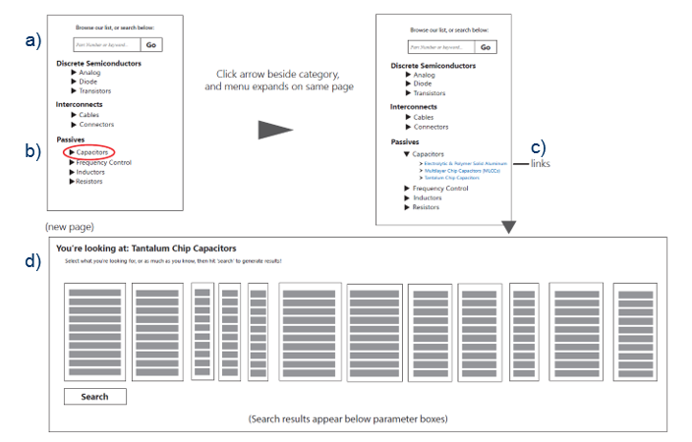

1. Industry Standards
   1. 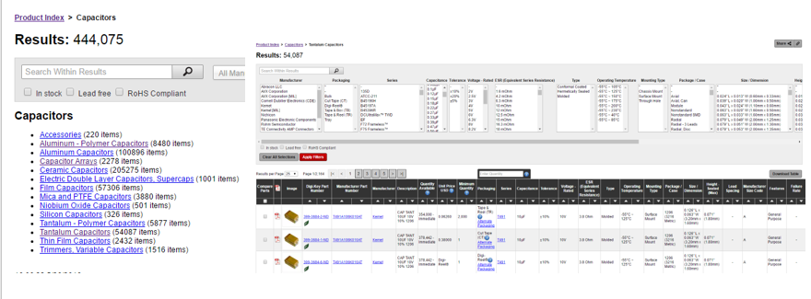Digikey.com
   2. Kemet.com

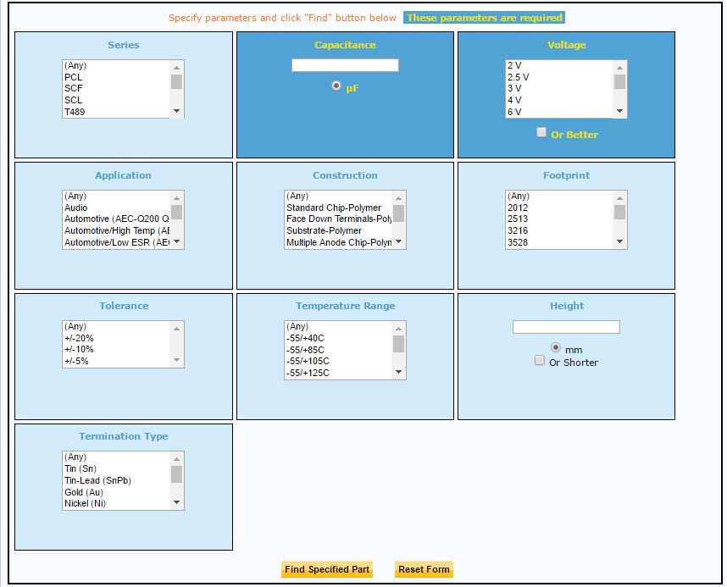

PREVIOUS BUSINESS REQUIREMENTS DOCUMENT TEMPLATE

**Enhancement <Ticket Number>**

**Requirement:** <NAME>

* **What is the result expected?**
* **Why this requirement is needed?**
* **When is required to complete?**
* **What should be done to deliver this requirement?**
* **What skill set should we involve to solution this requirement?**
* **What are the restrictions and what is Out of Scope?**
* **How would the user test the solution?**